ALISTAIR SPEED MEMORIAL 50
(INCORPORATING SVTTA HARRY ROBERTS)
SUNDAY 27 JUNE 2021
8.00 AM START
COURSE FI-8 (revised)

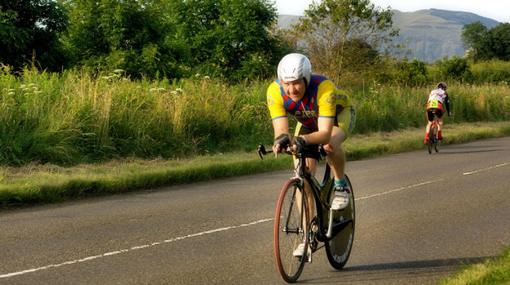

PROMOTED BY FIFE CYCLING ASSOCIATION
ON BEHALF OF CYCLING TIME TRIALS ASSOCIATION
UNDER THEIR RULES & REGULATIONS

Organiser: Mhairi Laffoley, 22 Frankfield Place, Dalgety Bay
Tel: 01383 822349 or email: mhairilaffoley@gmail.com

Alistair was introduced to the sport of cycling from a very young age by his dad, Archie, and he became a member of the Fife Century Road Club at the age of 8. He was to become a very active member and started competing at the age of 12 and continued to compete until his untimely death in September 2013 at the age of 49. He also regularly officiated at events and his time-keeping skills were second to none.

Over the years he travelled the length and breadth of the country, representing the Fife Century, taking part in events ranging from 10 miles to 12 hours, often having come straight from a night shift but he always had a smile and a friendly word for his fellow competitors and for those officiating.

Alistair was always at his happiest when cycling was involved and he was so proud that his nephew, Gavin, had taken up the family sport. They spent many hours together either at events or just going for a run on their bikes right up until the evening prior to his death.

It is hard to believe that it is nearly 8 years since we lost him, but the happy memories live on. I am sure that many of you will also have happy memories of time spent with Ali.

Event Headquarters (open from 7 am)
Freuchie Cricket Club, Muir Road, Freuchie KY15 7HW
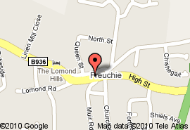
Parking
HQ
Weather permitting parking will be on the perimeter of the cricket club field at HQ, however, if we have had heavy rain prior to the event we are unable to park on their grounds. If this is the case parking will be available on-street or at car park in the centre of Freuchie, just off Lomond Road. Please do not block driveways, lowered kerbs, etc. Due to Covid restrictions we will not have access to changing rooms this year, but there will be toilet facilities.
PLEASE NOTE THERE WILL BE NO PARKING AT THE EVENT START

Parking
A92

PLEASE NOTE THAT IT IS NOW A DIFFERENT COURSE FROM THE PAST COUPLE OF YEARS
Parking

Warming Up

Start
The start is approx. 3 ½ miles from Cricket Club on unclassified road (near the village of Dunshalt) Proceed from the hall at mini roundabout take first junction and then immediate left. Continue on unclassified road to start point. Start on opposite side of road from 300 yds to go marker. Approx ¼ mile east of Dunshalt.
No room for parking or warming up at start line..

Course
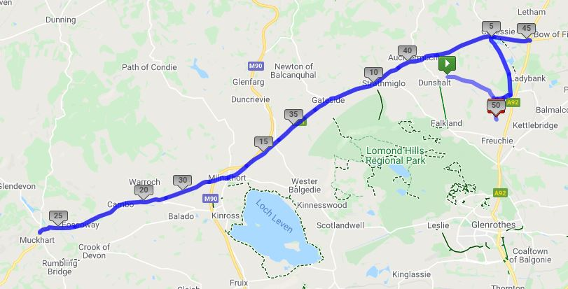
From start proceed along unclassified road to Shiels Triangle, turn left to Heatherhall Woods. Turn left onto (B937) to Trafalgar. Left on A91 and proceed to Milnathort. Straight over at mini roundabout remaining on A91 out to Yetts O Muckhart. Take right hand lane and follow one way section to return the way you came along A91 to Milnathort. Continue on A91 through Gateside and Auchtermuchty to Melvile Lodges roundabout. Circumvent roundabout and retrace along A91 for approx. 1 mile. Turn left onto B937 to Heatherhall Woods. Turn right (DO NOT CUT THIS CORNER) Left at Shiels Triangle and proceed to finish at the Alex Mackie Bench on unclassified road approx. 1 mile north of Freuchie village.

ATTENTION
The roundabout in Milnathort does not have good site lines especially on the return leg. Riders will have to slow down adequately as they will not see if the road is clear to continue until the last minute. Riders not slowing appropriately for the junction and felt to be riding dangerously will be disqualified.

The course will be well signposted and marshalled.

ATTENTION – GUIDANCE DUE TO COVID

EVENT HQ
- If you are not well or are showing any signs of covid please do not come to the event.
- We will have access to the Cricket Club grounds for parking (please park on the perimeter & not on the pitch)
- When parking please use common sense and do not block any gates. If using a turbo trainer to warm up please position this at front or back of your vehicle (to adhere to social distancing rules) although we would suggest that warm up be done out on the road
- Access to toilets (1 in/1 out) but NO access to changing rooms. Toilets should not be used for changing. You are asked not to change in full view of any residents. We are incredibly lucky to have this facility, so please do not give them any reason to take it away.
- When at registration desk please wear face covering
- Please bring your own pen for signing on and out. Remember CTT rules need you to sign out – if you do not sign out you will be DQd.
- On finishing return your number into the box provided.
- Please bring your own pins if you need them.

RACE
- There will be limited space at the start area (to meet social distancing) and therefore riders will be asked to arrive no more than 5 minutes before their start time, but remember to give yourself plenty of time to travel the 3 ½ miles from HQ to start.
- No pusher off – ALL riders will be required to start with one foot on the ground.
- Start timekeepers will NOT be able to bring jackets etc back to HQ. No responsibility will be taken for any jackets or personal belongings left at the start.
- Riders MUST have a working rear light fitted to their bikes. NO light NO start.
- Riders should NOT stop at the finish area and should continue to the HQ where they should SIGN OUT and place their number in the allocated box. NO socializing at the car park area – we know this is not the norm and socializing is a big part of racing but under the current circumstances we need to follow these restrictions to enable us to run events.

RESULTS
- There will be NO results available at the event. Results will be emailed out to each rider as soon as possible after the event. The results will also be posted on the CTT Webpage.

SUMMARY
- Please use common sense at all times due to the current situation that we are all living in. We want to make sure that everybody is safe plus we DO NOT want to give the general public any excuse to complain and have events stopped.

Thanks
Many thanks to all the volunteers helping today without them the race would not be able to go ahead. Thank you also to those of you who have generously donated towards the prize fund today, including the SVTTA.

Prizes

Due to the current covid guidelines there will be no presentation at the end of the event. Results will be emailed to all riders as well as being on the CTT webpage. Prize monies will be posted out to winners.

Mens Lady’s Vet’s Lady Vet
^{1st} ^{1st} ^{V40} ^{FV40}
^{2nd} ^{2nd} ^{V50} ^{FV50}
^{3rd} ^{3rd} ^{V60}
^{V70}

SVVTA Member on Standard SVTTA Lady Member on Standard SVTTA Team on Standard

Alistair Speed Spot Prize Lantern Rouge

One rider one prize apart from SVTTA prizes.

THERE WILL BE NO NUMBER 1 AS THIS HAS BEEN LEFT BLANK IN HONOUR OF ALISTAIR

FCA Open 50
No | NAME | CLUB | CAT | START | FINISH
1 |  |  |  | 8.01
2 | Dave Kirton | Kennoway RC | V50 | 8.02
3 | Fred Denton | St Christophers CC | V60 | 8.03
4 | Gerard Maguire | Pentland Velo | V60 | 8.04
5 | Andrew Wilson | St Christophers CC | V70 | 8.05
6 | Suzanne Matonti | Livingston CC | F | 8.06
7 | Miriam Rennet | Kinross CC | FV50 | 8.07
8 | Gavin Laffoley | Fife Century RC | S | 8.08
9 | Robert Brown | EH Star Racing | V70 | 8.09
10 | David Ross | Falkirk BC | V40 | 8.10
11 | Alan Manson | SVTTA | V50 | 8.11
12 | Mathew Matonti | Livingston CC | V40 | 8.12
13 |  |  |  | 8.13
14 | Chris Hunter | Glasgow Ivy CC | V40 | 8.14
15 | Alistair Merry | Dundee Thistle | S | 8.15
16 | Neil Anderson | Deeside Thistle CC | V50 | 8.16
17 | Sonya Drummond | Dundee Thistle CC | FV40 | 8.17
18 | Marc Preece | Smart121 | V40 | 8.18
19 | Iain Taylor | Dunfermline CC | V50 | 8.19
20 | Sean Quinn | Law Wheelers | V40 | 8.20
21 | Jonny May | Dundee Thistle | V50 | 8.21
22 | Patricia Baird | Ecosse Performance Cycling Coaching | FV50 | 8.22
23 | John Waller | EH Star Racing | S | 8.23
24 | Nigel Brooks | Flying Kippers | V60 | 8.24
25 | Angus Wilson | Team Andrew Allan Architecture | V50 | 8.25
26 | David Henderson | EH Star Cycling | V50 | 8.26
27 | Scott McCord | Carnoustie CC | S | 8.27
28 | Richard Sanderson | Kinross CC | S | 8.28
29 |  |  |  | 8.29
30 | Jimmy Storrar | Velocity 44 RT | S | 8.30
31 | Joanne Clark | Royal Albert | FV40 | 8.31
32 | Fraser Caldwell | Cromarty Firth CC | V40 | 8.32
33 | Stuart MacCallum | Team Andrew Allan Architecture | V40 | 8.33
34 | Allan Ross | Fruin RC | V60 | 8.34
35 | Derek McMillan | St Christophers CC | V60 | 8.35
36 | Rab Marshall | Team Andrew Allan Architecture | V40 | 8.36
37 | Neil McLeod | SVTTA | V40 | 8.37
38 | Ray Wilson | Ryan’s Bike Surgery/Thomson Homes | V40 | 8.38
39 | Andrew Gallacher | Livingston CC | V50 | 8.39
40 | Christina Murray | Army Cycling | FV40 | 8.40
41 | Stuart MacKay | Dunfermline CC | S | 8.41
42 | Bill Groves | EH Star Cycling | V50 | 8.42
43 | Alan Dean | Edinburgh RC | S | 8.43
44 |  |  |  | 8.44
45 | Hans Farshaug | Glasgow United CC | V50 | 8.45
46 | Gary Bratt | Fruin RC | V40 | 8.46
47 | Frank Anderson | SVTTA | V60 | 8.47
48 | Graham Jones | Edinburgh RC | V50 | 8.48
49 | David Reeves | Dundee Thistle | V40 | 8.49
50 | Robbie Mitchell | Auchencrow Thistle | V40 | 8.50
51 | Alan Davidson | Dundee Thistle | V60 | 8.51
52 | Ian Dobbie | West Lothian Clarion | V50 | 8.52
53 | Randle Shenton | Legato Racing Team | V60 | 8.53
54 |  |  |  | 8.54
55 | Silas Goldsworthy | Ryan’s Bike Surgery/Thomson Homes | S | 8.55
56 |  |  |  | 8.56
57 |  |  |  | 8.57
58 |  |  |  | 8.58
59 |  |  |  | 8.59
60 |  |  |  | 9.00
61 |  |  |  | 9.01
62 |  |  |  | 9.02
63 |  |  |  | 9.03
64 |  |  |  | 9.04
65 |  |  |  | 9.05
66 |  |  |  | 9.06
67 |  |  |  | 9.07

